SIMATS ENGINEERING
ASSESSMENT TOOL 3
CO2 – AT3 - Dry Run Evaluation (Solutions with Program Code)

Question 1: Greedy Best-First Search Data.

Undirected road network with step costs and heuristic values h(n) (estimated cost to goal G):
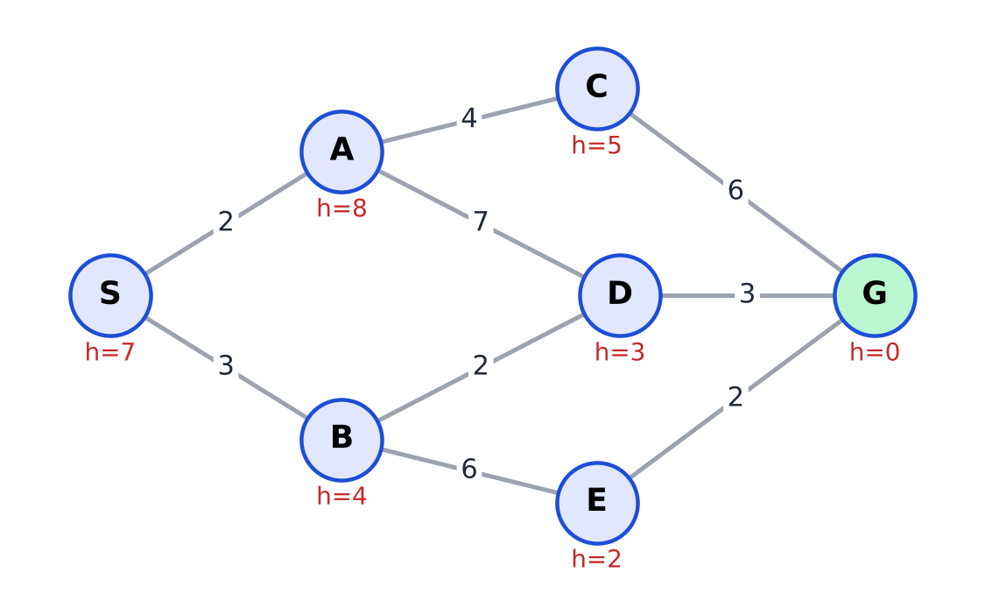
Figure 1: Road network with step costs and heuristic values h(n)
Method. Greedy best-first search keeps an open list ordered only by h(n). At each step it expands the node with the smallest h(n), adds its unvisited neighbours (with their h values) to the open list, and stops when G is expanded. Cost g(n) is ignored.

(a) Dry run table
Initial open list: S:7.
Step | Node expanded | Nodes added to open list | Open list after expansion (node: h)
1 | S (h = 7) | A:8, B:4 | B:4, A:8
2 | B (h = 4) | D:3, E:2 | E:2, D:3, A:8
3 | E (h = 2) | G:0 | G:0, D:3, A:8
4 | G (h = 0) – GOAL | – | D:3, A:8
Order of expansion: S, B, E, G. Closed list at the end: {S, B, E, G}.

(b) Path found and total cost
Path: S → B → E → G Cost = 3 + 6 + 2 = 11.

(c) Is the path optimal? (2 marks)
No. Consider the alternative path S → B → D → G, whose cost is 3 + 2 + 3 = 8, which is less than 11. The other two paths, S → A → C → G (2 + 4 + 6 = 12) and S → A → D → G (2 + 7 + 3 = 12), are more expensive, so the optimal cost is 8.
Reason: at B the algorithm chose E (h = 2) over D (h = 3) because it looks only at the estimated remaining cost and ignores the cost already paid. The edge B–E costs 6 whereas B–D costs only 2, so the apparently “closer” node led to a more expensive route. Greedy search is therefore fast but neither optimal nor guaranteed to find the cheapest path.
Program :
"""
Q1 Greedy Best-First Search
"""
import heapq
from math import inf

# ---------------------------------------------------------------
# Road network (undirected) and heuristic values h(n)
# ---------------------------------------------------------------
EDGES = [("S", "A", 2), ("S", "B", 3), ("A", "C", 4), ("A", "D", 7),
("B", "D", 2), ("B", "E", 6), ("C", "G", 6), ("D", "G", 3),
("E", "G", 2)]
H = {"S": 7, "A": 8, "B": 4, "C": 5, "D": 3, "E": 2, "G": 0}

GRAPH = {n: {} for n in H}
for u, v, c in EDGES:
GRAPH[u][v] = c
GRAPH[v][u] = c

def path_cost(path):
return sum(GRAPH[a][b] for a, b in zip(path, path[1:]))

def build_path(parent, goal):
path, node = [], goal
while node is not None:
path.append(node)
node = parent[node]
return path[::-1]

# ---------------------------------------------------------------
# Q1 - Greedy Best-First Search : priority = h(n)
# ---------------------------------------------------------------
def greedy_best_first(start, goal):
open_list = {start: H[start]}
parent = {start: None}
closed = set()
steps = []
while open_list:
node = min(open_list, key=lambda n: (open_list[n], n))
del open_list[node]
closed.add(node)
if node == goal:
steps.append((node, dict(open_list)))
break
for nb in GRAPH[node]:
if nb not in closed and nb not in open_list:
open_list[nb] = H[nb]
parent[nb] = node
steps.append((node, dict(open_list)))
return build_path(parent, goal), steps

Output :

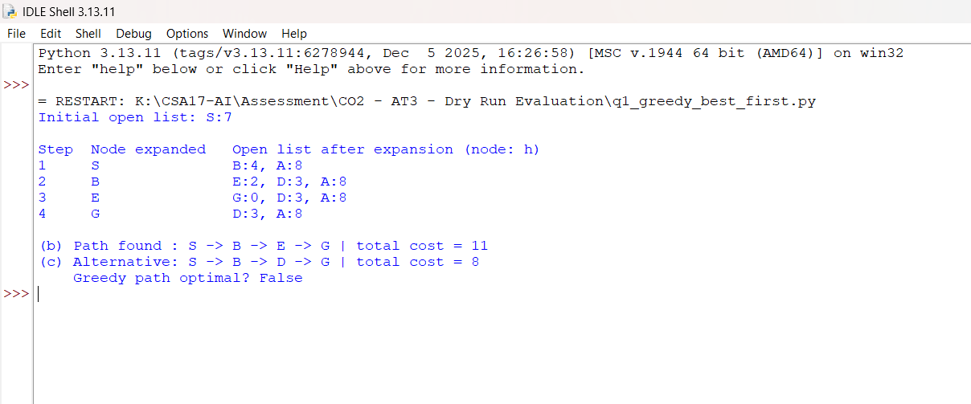

Question 2: A* Search Method.

A* orders the open list by f(n) = g(n) + h(n), where g(n) is the cheapest known cost from S to n. If a cheaper route to a node is found, its g and parent are updated. The search stops when G is removed from the open list.

(a) Dry run table
Initial open list: S: 0 + 7 = 7.
Step | Node expanded (g + h = f) | Open list after expansion (node: g + h = f)
1 | S (0 + 7 = 7) | B: 3 + 4 = 7, A: 2 + 8 = 10
2 | B (3 + 4 = 7) | D: 5 + 3 = 8, A: 2 + 8 = 10, E: 9 + 2 = 11
3 | D (5 + 3 = 8) | G: 8 + 0 = 8, A: 2 + 8 = 10, E: 9 + 2 = 11
4 | G (8 + 0 = 8) – GOAL | A: 2 + 8 = 10, E: 9 + 2 = 11
Notes: in step 2, g(D) = g(B) + 2 = 5 and g(E) = g(B) + 6 = 9. In step 3, going from D to A would give g(A) = 5 + 7 = 12, which is worse than the existing g(A) = 2, so A is not updated; G gets g(G) = 5 + 3 = 8. Order of expansion: S, B, D, G.

(b) Path, cost and comparison with Question 1
Path: S → B → D → G Cost = 3 + 2 + 3 = 8.
 | Greedy (Q1) | A* (Q2)
Evaluation function | h(n) | g(n) + h(n)
Nodes expanded | S, B, E, G (4) | S, B, D, G (4)
Path found | S → B → E → G | S → B → D → G
Path cost | 11 | 8
Optimal? | No | Yes
A* expanded the same number of nodes as greedy search here but returned a path that is 3 units cheaper, because after B it compared f(D) = 8 with f(E) = 11 and correctly preferred D. Greedy search only compared h(D) = 3 with h(E) = 2.

(c) Admissibility of h(n)
A heuristic is admissible if h(n) ≤ h*(n) for every node, where h*(n) is the true cheapest remaining cost to G. The true costs below were obtained by inspecting the cheapest paths (and confirmed with Dijkstra’s algorithm in the program):
Node | Cheapest path to G | True cost h*(n) | h(n) | h(n) ≤ h*(n)?
S | S → B → D → G = 3 + 2 + 3 | 8 | 7 | Yes (7 ≤ 8)
A | A → D → G = 7 + 3 (or A → C → G = 4 + 6) | 10 | 8 | Yes (8 ≤ 10)
B | B → D → G = 2 + 3 | 5 | 4 | Yes (4 ≤ 5)
C | C → G = 6 | 6 | 5 | Yes (5 ≤ 6)
D | D → G = 3 | 3 | 3 | Yes (3 ≤ 3)
E | E → G = 2 | 2 | 2 | Yes (2 ≤ 2)
Conclusion: h(n) never overestimates, so it is admissible (all six non-goal nodes were checked, and h(G) = 0). It is also consistent: h(u) ≤ c(u, v) + h(v) holds for every edge.
Why it matters: A* with an admissible heuristic is guaranteed to return an optimal solution, because f(n) never overestimates the cost of the best path through n, so a cheaper path can never be hidden behind a node with a larger f value. If h overestimated (for example h(D) = 9), A* could ignore the good route S → B → D → G and return a costlier one. With a consistent heuristic, A* also never needs to re-expand a closed node.
Program 1: Greedy Best-First Search and A* (Questions 1 and 2) – q1_q2_search.py

# ---------------------------------------------------------------
# Q2 - A* Search : priority = f(n) = g(n) + h(n)
# ---------------------------------------------------------------
def a_star(start, goal):
g = {start: 0}
parent = {start: None}
open_list = {start: H[start]} # node -> f
closed = set()
steps = []
while open_list:
node = min(open_list, key=lambda n: (open_list[n], n))
del open_list[node]
if node == goal:
steps.append((node, {n: (g[n], H[n], g[n] + H[n]) for n in open_list}))
break
closed.add(node)
for nb, cost in GRAPH[node].items():
new_g = g[node] + cost
if new_g < g.get(nb, inf):
g[nb] = new_g
parent[nb] = node
open_list[nb] = new_g + H[nb]
closed.discard(nb)
steps.append((node, {n: (g[n], H[n], g[n] + H[n]) for n in open_list}))
return build_path(parent, goal), g[goal], steps
# ---------------------------------------------------------------
# Admissibility check : true remaining cost h*(n) by Dijkstra from G
# ---------------------------------------------------------------
def true_costs(goal):
dist = {n: inf for n in GRAPH}
dist[goal] = 0
pq = [(0, goal)]
while pq:
d, u = heapq.heappop(pq)
if d > dist[u]:
continue
for v, c in GRAPH[u].items():
if d + c < dist[v]:
dist[v] = d + c
heapq.heappush(pq, (dist[v], v))
return dist
def show_open_greedy(open_dict):
items = sorted(open_dict.items(), key=lambda kv: (kv[1], kv[0]))
return ", ".join(f"{n}:{h}" for n, h in items) or "(empty)"
def show_open_astar(open_dict):
items = sorted(open_dict.items(), key=lambda kv: (kv[1][2], kv[0]))
return ", ".join(f"{n}:{g}+{h}={f}" for n, (g, h, f) in items) or "(empty)"

if __name__ == "__main__":
print("=== Q1 : GREEDY BEST-FIRST SEARCH ===")
path, steps = greedy_best_first("S", "G")
for i, (node, op) in enumerate(steps, 1):
print(f"Step {i}: expand {node:<2} open = {show_open_greedy(op)}")
print("Path :", " -> ".join(path), "| cost =", path_cost(path))
alt = ["S", "B", "D", "G"]
print("Alternative path:", " -> ".join(alt), "| cost =", path_cost(alt))

print("\n=== Q2 : A* SEARCH ===")
path, cost, steps = a_star("S", "G")
for i, (node, op) in enumerate(steps, 1):
print(f"Step {i}: expand {node:<2} open = {show_open_astar(op)}")
print("Path :", " -> ".join(path), "| cost =", cost)

print("\n=== Admissibility check ===")
true = true_costs("G")
print(f"{'Node':<5}{'h(n)':<6}{'h*(n)':<7}admissible?")
for n in "SABCDEG":
print(f"{n:<5}{H[n]:<6}{true[n]:<7}{H[n] <= true[n]}")
print("All admissible:", all(H[n] <= true[n] for n in H))
consistent = all(H[u] <= c + H[v] for u in GRAPH for v, c in GRAPH[u].items())
print("Consistent :", consistent)
Output :
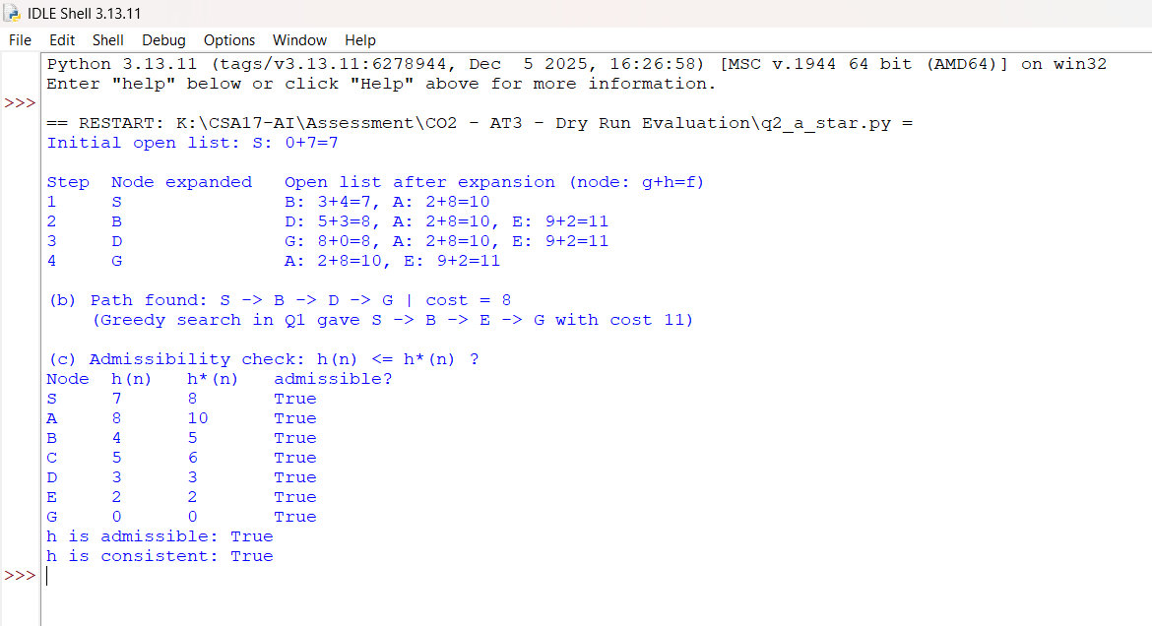

Question 3: Constraint Satisfaction Problem

(a) CSP formulation and constraint graph
- Variables: WA, NT, SA, Q, NSW, V (the six regions).
- Domains: D(WA) = D(NT) = D(SA) = D(Q) = D(NSW) = D(V) = {R, G, B}.
- Constraints (binary, ≠): WA ≠ NT, WA ≠ SA, NT ≠ SA, NT ≠ Q, SA ≠ Q, SA ≠ NSW, SA ≠ V, Q ≠ NSW, NSW ≠ V (9 constraints – one per pair of neighbouring regions).
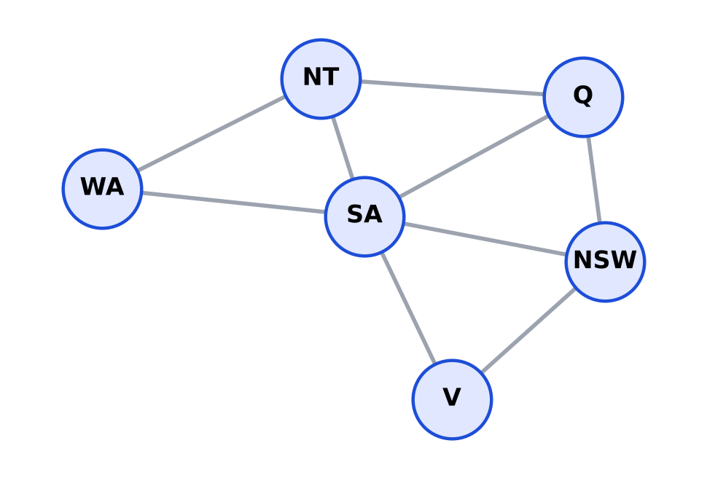
Figure 2: Constraint graph (nodes = regions, edges = “must differ in colour”)
Degrees: SA = 5, NT = 3, Q = 3, NSW = 3, WA = 2, V = 2 (sum 18 = 2 × 9 edges).

(b) Backtracking with forward checking, MRV and degree heuristic
Procedure: select the unassigned variable with the fewest legal values (MRV); break ties by the largest number of unassigned neighbours (degree); then by the order WA, NT, SA, Q, NSW, V. Try colours in the order R, G, B. After each assignment, forward checking removes that colour from the domains of unassigned neighbours; an empty domain would force backtracking.
Initial domains: WA {R,G,B}, NT {R,G,B}, SA {R,G,B}, Q {R,G,B}, NSW {R,G,B}, V {R,G,B}.
Step | Variable chosen (reason) | Assign | Forward checking removes | Domains of unassigned regions afterwards
1 | All domains size 3 → highest degree: SA (5) | SA = R | R from WA, NT, Q, NSW, V | WA{G,B} NT{G,B} Q{G,B} NSW{G,B} V{G,B}
2 | MRV tie (all 2); degree NT = Q = NSW = 2 → order picks NT | NT = G | G from WA, Q | WA{B} Q{B} NSW{G,B} V{G,B}
3 | MRV tie WA{B}, Q{B}; degree WA = 0, Q = 1 → Q | Q = B | B from NSW | WA{B} NSW{G} V{G,B}
4 | MRV tie WA{B}, NSW{G}; degree WA = 0, NSW = 1 → NSW | NSW = G | G from V | WA{B} V{B}
5 | MRV tie WA{B}, V{B}; degree 0 = 0 → order picks WA | WA = B | nothing (no unassigned neighbours) | V{B}
6 | Only V left | V = B | nothing | – (all assigned)
Final colouring: SA = Red, NT = Green, Q = Blue, NSW = Green, WA = Blue, V = Blue. Check: WA–NT (B,G), WA–SA (B,R), NT–SA (G,R), NT–Q (G,B), SA–Q (R,B), SA–NSW (R,G), SA–V (R,B), Q–NSW (B,G), NSW–V (G,B) – all different. The search needed 6 assignments and no backtracking.

(c) Effect of the MRV and degree heuristics
- MRV (fail-first): choosing the variable with the fewest remaining values means the most constrained region is coloured first, so conflicts show up early and wrong branches are cut near the root instead of deep in the tree. In the run above, after SA = R and NT = G, the regions WA and Q were already down to a single value, so they were assigned next and their colours were forced – no branching at all.
- Degree heuristic (tie-breaker): at the start every region has three colours, so MRV cannot decide. Choosing SA, which touches five other regions, lets forward checking prune the most values in one move (it reduced every other domain from 3 to 2). Later, picking Q (degree 1) before WA (degree 0) also leaves fewer constraints on the remaining variables.
- Together they reduce the effective branching factor and the number of nodes explored; here the whole solution was found with the minimum possible 6 assignments and zero backtracks.

Program : Backtracking + Forward Checking + MRV + Degree (Question 3) – q3_csp.py
"""
Q3 - CSP (map colouring) : backtracking + forward checking + MRV + degree heuristic
"""
VARS = ["WA", "NT", "SA", "Q", "NSW", "V"]
DOMAIN = ["R", "G", "B"]
EDGES = [("WA", "NT"), ("WA", "SA"), ("NT", "SA"), ("NT", "Q"), ("SA", "Q"),
("SA", "NSW"), ("SA", "V"), ("Q", "NSW"), ("NSW", "V")]
NB = {v: set() for v in VARS}
for a, b in EDGES:
NB[a].add(b)
NB[b].add(a)
def fmt(domains, assigned):
return " ".join(f"{v}:{{{','.join(domains[v])}}}" for v in VARS if v not in assigned)
def select_variable(domains, assigned):
unassigned = [v for v in VARS if v not in assigned]
# MRV -> degree (most unassigned neighbours) -> fixed order
return min(unassigned,
key=lambda v: (len(domains[v]),
-len([n for n in NB[v] if n not in assigned]),
VARS.index(v)))
def backtrack(assigned, domains, log, depth=0):
if len(assigned) == len(VARS):
return assigned
var = select_variable(domains, assigned)
for colour in DOMAIN:
if colour not in domains[var]:
continue
new_assigned = dict(assigned, **{var: colour})
new_domains = {v: list(d) for v, d in domains.items()}
new_domains[var] = [colour]
pruned, failed = [], False
for n in NB[var]: # forward checking
if n not in new_assigned and colour in new_domains[n]:
new_domains[n].remove(colour)
pruned.append(n)
if not new_domains[n]:
failed = True
log.append((depth + 1, var, colour, fmt(new_domains, new_assigned),
pruned, "DEAD END - backtrack" if failed else ""))
if not failed:
result = backtrack(new_assigned, new_domains, log, depth + 1)
if result:
return result
return None
if __name__ == "__main__":
domains = {v: list(DOMAIN) for v in VARS}
log = []
solution = backtrack({}, domains, log)
print("Initial domains:", fmt(domains, {}))
for i, (d, var, col, doms, pruned, note) in enumerate(log, 1):
print(f"Step {i}: assign {var}={col} | removed {col} from {pruned or '-'}")
print(" domains ->", doms or "(all assigned)", note)
print("\nFinal colouring:", solution)
ok = all(solution[a] != solution[b] for a, b in EDGES)
print("All constraints satisfied:", ok)
Output :
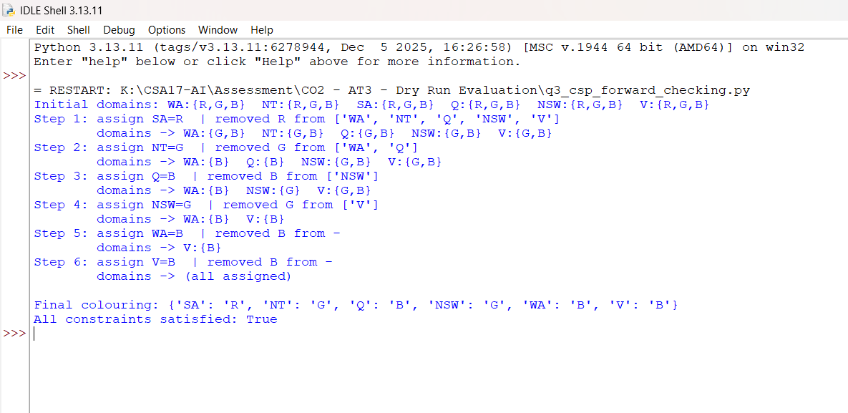

Question 4: Minimax with a Heuristic Evaluation Function

(a) Minimax backed-up values
Naming: A is the root (MAX); B1, B2 are the MIN children; C1–C4 are the MAX grandchildren; the eight leaves are, left to right, 3, 5 | 6, 9 | 1, 2 | 0, −1. MAX nodes take the maximum of their children, MIN nodes the minimum.
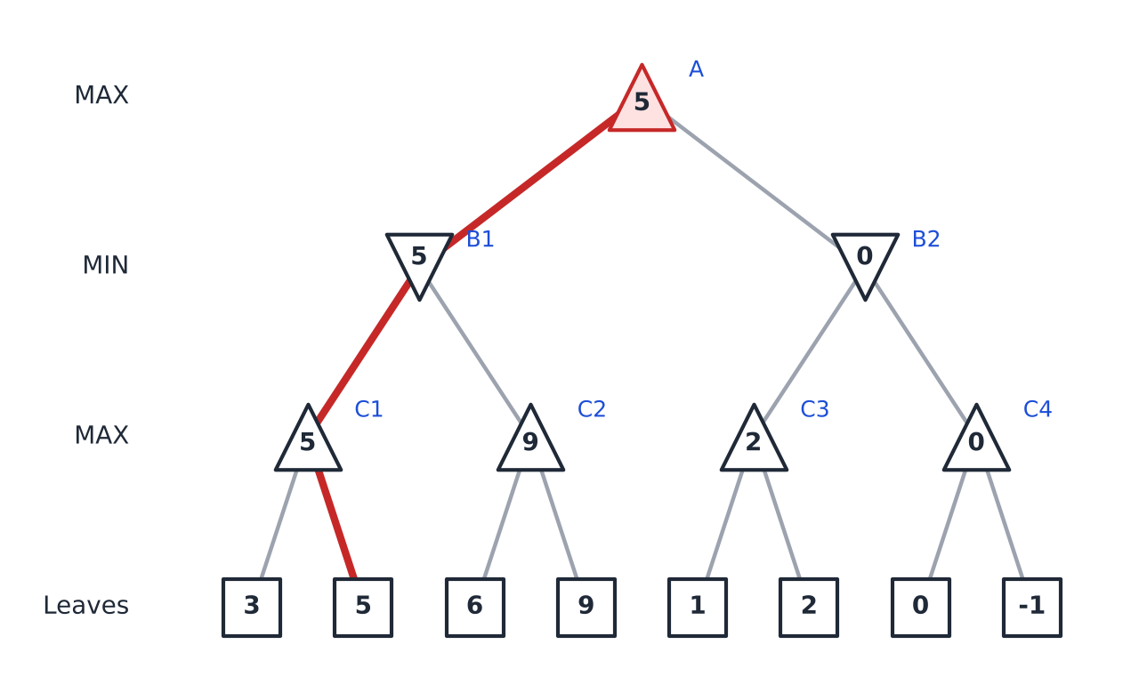
Figure 3: Game tree with backed-up minimax values (red = principal variation)
Node | Type | Children values | Backed-up value
C1 | MAX | max(3, 5) | 5
C2 | MAX | max(6, 9) | 9
C3 | MAX | max(1, 2) | 2
C4 | MAX | max(0, −1) | 0
B1 | MIN | min(C1, C2) = min(5, 9) | 5
B2 | MIN | min(C3, C4) = min(2, 0) | 0
A (root) | MAX | max(B1, B2) = max(5, 0) | 5

(b) Best first move and principal variation
Best first move: Left (to B1), because it is worth 5 against 0 for the right move. The minimax value of the game is 5.
Principal variation: A (MAX) → B1 (MIN) → C1 (MAX) → leaf 5. That is, MAX moves left, MIN then chooses C1 (value 5, smaller than C2’s 9), and MAX finally takes the right leaf of C1 (5 is larger than 3).

(c) Heuristic evaluation of the tic-tac-toe board
E = (number of lines still open for X) − (number of lines still open for O). A line is open for X if it contains no O, and open for O if it contains no X In the board shown, X occupies the top-left and centre squares and O occupies the top-middle and bottom-right squares.
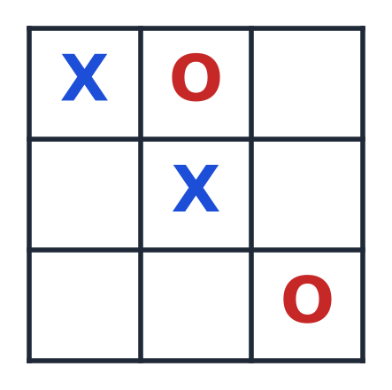
Figure 4: The board
Line | Cells | Open for X? | Open for O?
Row 1 (top) | X, O, – | No (has O) | No (has X)
Row 2 (middle) | –, X, – | Yes | No (has X)
Row 3 (bottom) | –, –, O | No (has O) | Yes
Column 1 | X, –, – | Yes | No (has X)
Column 2 | O, X, – | No (has O) | No (has X)
Column 3 | –, –, O | No (has O) | Yes
Diagonal (top-left to bottom-right) | X, X, O | No (has O) | No (has X)
Diagonal (top-right to bottom-left) | –, X, – | Yes | No (has X)
Total |  | 3 | 2
E = 3 − 2 = +1 (slightly favourable for X).

Program 4 :
"""
Q4 - Minimax on the given game tree + tic-tac-toe evaluation function E
"""

# ===================== Q4 (a), (b) : Minimax =====================
LEAVES4 = [3, 5, 6, 9, 1, 2, 0, -1]

def minimax_q4(leaves):
max_nodes = [max(leaves[i], leaves[i + 1]) for i in range(0, 8, 2)] # C1..C4
min_nodes = [min(max_nodes[0], max_nodes[1]),
min(max_nodes[2], max_nodes[3])] # B1, B2
root = max(min_nodes) # A
return max_nodes, min_nodes, root

# ============ Q4 (c) : E = (lines open for X) - (lines open for O) ============
LINES = [[(0, 0), (0, 1), (0, 2)], [(1, 0), (1, 1), (1, 2)], [(2, 0), (2, 1), (2, 2)],
[(0, 0), (1, 0), (2, 0)], [(0, 1), (1, 1), (2, 1)], [(0, 2), (1, 2), (2, 2)],
[(0, 0), (1, 1), (2, 2)], [(0, 2), (1, 1), (2, 0)]]
NAMES = ["Row 1", "Row 2", "Row 3", "Col 1", "Col 2", "Col 3", "Diag \\", "Diag /"]
BOARD = [["X", "O", " "],
[" ", "X", " "],
[" ", " ", "O"]]

def evaluate(board):
open_x = open_o = 0
detail = []
for name, line in zip(NAMES, LINES):
cells = [board[r][c] for r, c in line]
x_open = "O" not in cells # no O in the line -> still open for X
o_open = "X" not in cells # no X in the line -> still open for O
open_x += x_open
open_o += o_open
detail.append((name, cells, x_open, o_open))
return open_x, open_o, detail

Output :
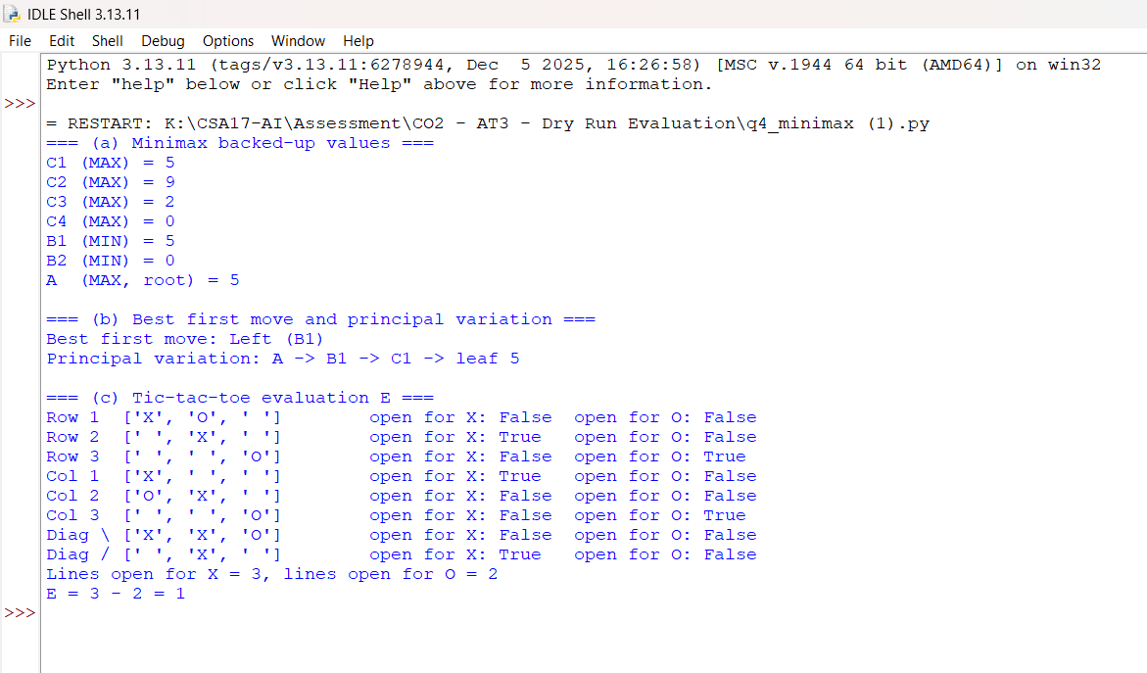

Question 5: Alpha-Beta Pruning
Tree: depth 4, binary. Levels: root A (MAX) → B1, B2 (MIN) → C1–C4 (MAX) → D1–D8 (MIN) → 16 leaves. Leaves left to right: 8, 6 | 5, 7 | 2, 9 | 4, 3 | 6, 1 | 5, 2 | 9, 7 | 3, 4 (each pair is under one of D1–D8). Children are visited left to right, starting with (α, β) = (−∞, +∞). A branch is cut when α ≥ β.

(a) Alpha-beta trace, pruned branches and root value (6 marks)
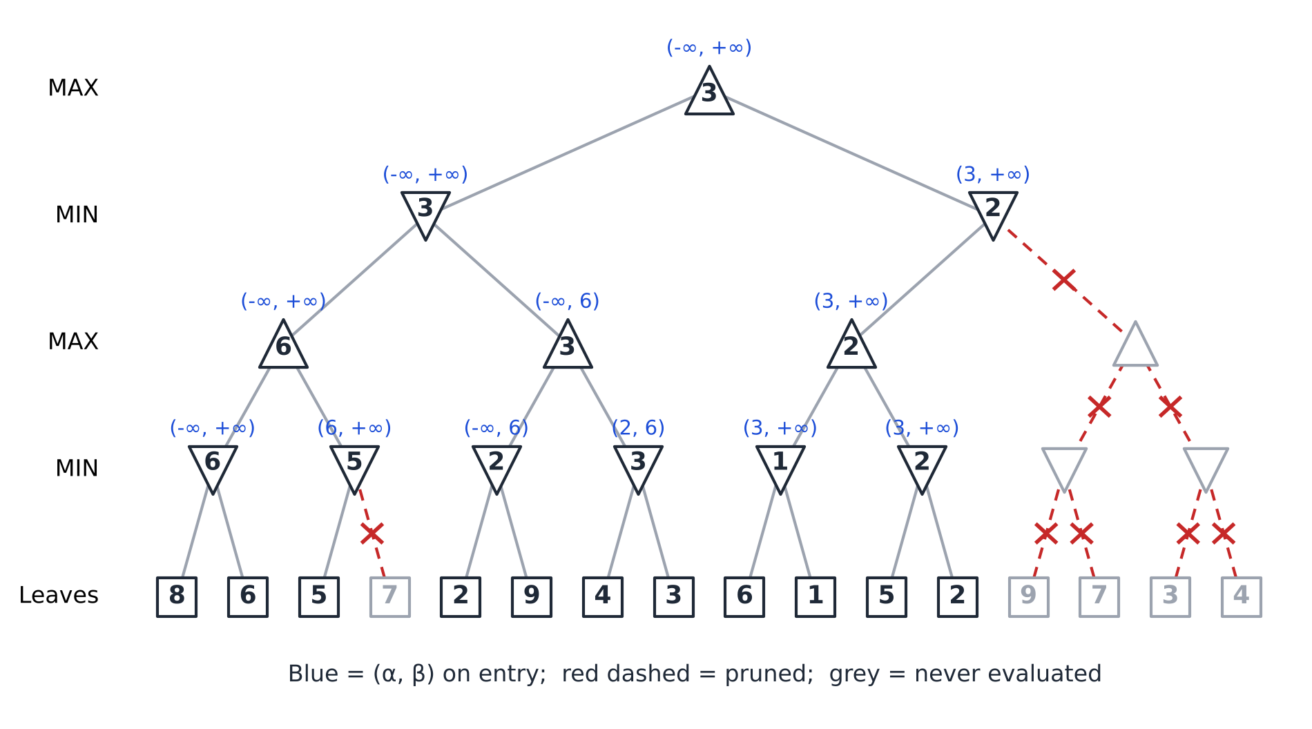
Figure 5: Alpha-beta search tree (blue = (α, β) on entry, red dashed = pruned)
Node | Type | (α, β) on entry | What happens | Returns
A | MAX | (−∞, +∞) | Visits B1, then B2; final α = 3 | 3
B1 | MIN | (−∞, +∞) | C1 = 6 gives β = 6; C2 = 3 gives β = 3 | 3
C1 | MAX | (−∞, +∞) | D1 = 6 gives α = 6; D2 = 5 (no change) | 6
D1 | MIN | (−∞, +∞) | leaf 8 → β = 8; leaf 6 → β = 6 | 6
D2 | MIN | (6, +∞) | leaf 5 → β = 5 ≤ α = 6: CUT-OFF, leaf 7 PRUNED | 5
C2 | MAX | (−∞, 6) | D3 = 2 gives α = 2; D4 = 3 gives α = 3 | 3
D3 | MIN | (−∞, 6) | leaf 2 → β = 2; leaf 9 (no change) | 2
D4 | MIN | (2, 6) | leaf 4 → β = 4; leaf 3 → β = 3 (> α = 2, no cut) | 3
B2 | MIN | (3, +∞) | C3 = 2 gives β = 2 ≤ α = 3: CUT-OFF, C4 PRUNED | 2
C3 | MAX | (3, +∞) | D5 = 1, D6 = 2; α stays 3 | 2
D5 | MIN | (3, +∞) | leaf 6 → β = 6; leaf 1 → β = 1 (≤ α, but no sibling left to prune) | 1
D6 | MIN | (3, +∞) | leaf 5 → β = 5; leaf 2 → β = 2 (≤ α, no sibling left) | 2
C4, D7, D8 | – | not visited | Pruned: leaves 9, 7, 3, 4 never evaluated | –
Pruned branches: (1) the right leaf (7) under D2, because β = 5 ≤ α = 6; (2) the whole subtree C4 (D7 and D8, leaves 9, 7, 3, 4) under B2, because B2’s β = 2 ≤ α = 3 from the root.
Value of the root: 3 (A = max(B1, B2) = max(3, 2)). MAX’s best move is the left branch to B1.

(b) Number of leaves evaluated and comparison with minimax (2 marks)
 | Plain minimax | Alpha-beta
Leaves evaluated | 16 | 11 (8, 6, 5, 2, 9, 4, 3, 6, 1, 5, 2)
Leaves skipped | 0 | 5 (7, 9, 7, 3, 4) – about 31% fewer
Root value | 3 | 3
Plain minimax gives D-level values 6, 5, 2, 3, 1, 2, 7, 3, then C values 6, 3, 2, 7, then B1 = min(6, 3) = 3, B2 = min(2, 7) = 2 and root = max(3, 2) = 3. Alpha-beta returns the same root value, 3, as it must: pruning only removes branches that cannot affect the final decision.

(c) Effect of move ordering (2 marks)
Alpha-beta pruning removes more of the tree when the best moves are examined first, because tight bounds (α for MAX, β for MIN) are established early and later siblings can be cut quickly. With perfect ordering the number of nodes examined is about O(b^(d/2)), so the search can go roughly twice as deep in the same time; with the worst ordering nothing is pruned and the cost is O(b^d), the same as minimax.
Example from this tree: D2 has leaves (5, 7) under α = 6. Because 5 is looked at first, β = 5 ≤ 6 immediately and leaf 7 is skipped. If the order were (7, 5), the 7 would have to be evaluated first (β = 7 > 6) and both leaves would be examined, so no pruning would occur. In practice good ordering is obtained with heuristics such as trying captures or previous best moves first, or by iterative deepening.
Program 5: tic-tac-toe evaluation and Alpha-Beta (Questions 5) – q5_games.py

# ===================== Q5 : Alpha-Beta pruning =====================
LEAVES5 = [8, 6, 5, 7, 2, 9, 4, 3, 6, 1, 5, 2, 9, 7, 3, 4]
INF = float("inf")

def plain_minimax(depth, index, is_max, leaves, counter):
if depth == 4:
counter[0] += 1
return leaves[index]
vals = [plain_minimax(depth + 1, 2 * index + i, not is_max, leaves, counter)
for i in (0, 1)]
return max(vals) if is_max else min(vals)

def alpha_beta(depth, index, is_max, alpha, beta, leaves, stats, name):
if depth == 4: # leaf
stats["leaves"] += 1
stats["trace"].append(f"{name}: leaf = {leaves[index]}")
return leaves[index]
stats["trace"].append(f"{name} ({'MAX' if is_max else 'MIN'}) "
f"entry alpha={alpha} beta={beta}")
value = -INF if is_max else INF
for i in (0, 1):
v = alpha_beta(depth + 1, 2 * index + i, not is_max,
alpha, beta, leaves, stats, f"{name}{i}")
if is_max:
value = max(value, v)
alpha = max(alpha, value)
else:
value = min(value, v)
beta = min(beta, value)
if alpha >= beta: # cut-off
if i == 0:
stats["pruned"].append(
f"{name}1 pruned (alpha={alpha} >= beta={beta})")
break
stats["trace"].append(f"{name} returns {value}")
return value

if __name__ == "__main__":
print("=== Q4(a),(b) Minimax ===")
mx, mn, root = minimax_q4(LEAVES4)
print("MAX nodes C1..C4:", mx)
print("MIN nodes B1,B2 :", mn)
print("Root A :", root)
print("Best first move :", "Left (B1)" if mn[0] >= mn[1] else "Right (B2)")

print("\n=== Q4(c) Tic-tac-toe evaluation ===")
ox, oo, detail = evaluate(BOARD)
for name, cells, xo, oo_ in detail:
print(f"{name:<7}{str(cells):<22} open for X: {xo!s:<6} open for O: {oo_}")
print(f"Lines open for X = {ox}, for O = {oo}, E = {ox - oo}")

print("\n=== Q5 Alpha-Beta ===")
stats = {"leaves": 0, "trace": [], "pruned": []}
root5 = alpha_beta(0, 0, True, -INF, INF, LEAVES5, stats, "n")
print("\n".join(stats["trace"]))
print("\nPruned branches:", *stats["pruned"], sep="\n ")
counter = [0]
root_plain = plain_minimax(0, 0, True, LEAVES5, counter)
print(f"\nAlpha-beta : root = {root5}, leaves evaluated = {stats['leaves']}")
print(f"Minimax : root = {root_plain}, leaves evaluated = {counter[0]}")
print("Same root value:", root5 == root_plain)

Output :
